***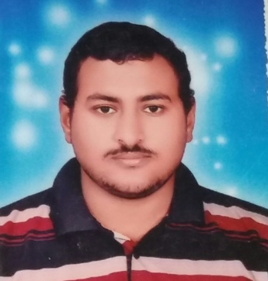* CURRICULUM VITAE**

**Khalid Ahmed Youssef Farghly**

|  |  |
| --- | --- |
|  | **۞ PERSONAL DATA :-** |
| **: Khalid Ahmed Youssef** | * ***Name*** |
| **5 / 6 / 1993:** | * ***Birth of date*** |
| **: Assuit** | * ***Birth Place*** |
| **: Assuit-first Assyit** | * ***Address*** |
| **: Male.** | * ***Gender*** |
| **: Engaged** | * ***Marital Status*** |
| **: Is passed.** | * ***Military Service*** |
| **Home +20889200360** | * ***Phone No.*** |
| **: 01011325958** | * ***Mobile No*.** |
| **: Egyptian.** | * ***Nationality*** |
| [**Ka2315801@gmail.com**](mailto:Ka2315801@gmail.com)  **:** | * ***E-mail Address*** |
|  | **EDUCATION :- ۞** |
| **: Assiut.** | * ***University*** |
| **: Agriculture.** | * ***Faculty*** |
| **: Excellent (with Honor Degree).** | * ***Final Grade*** |
| **: 2015** | * ***Graduation year*** |
| **: B.Sc of Agriculture**  **Soil and Water Department.** | * ***Qualification*** |
|  | **PERSONAL SKILLS:- ۞** |
| **: Good In Both Spoken and Written** | * ***English Language*** |
|  |  |
| **Demonistrator in Soil and Water Department, Faculty of Agriculture, Assiut University** | * **Current Position** |
|  |  |
|  |  |
|  |  |